### **BIA WORKSHOP – POWER BI USING DAX LAB 4 – Data communication and DAX**

### Prepared exclusively for 2023 BIA Graduating Seniors (with an INFO 3300 prereq)

May 2023

## **LAB RESOURCES**

|  |  |
| --- | --- |
|  | DIAD Lab 3.pbix |

**NOTE:** For this lab, we focus on communicating data via a dashboard (e.g., replicating the JHU Coronavirus Resource Center)**.**

## **LESSON 1: BUILDING A DASHBOARD AND DAX**

Import **global vaccination data** from<https://raw.githubusercontent.com/govex/COVID-19/master/data_tables/vaccine_data/global_data/time_series_covid19_vaccine_global.csv>

There is **no need for any transformations**

**Rename** the dataset **Vaccinations_CCI**

**No need to create a relationship** to any of the other datasets (you can, there is a relationship to World Population, but the dashboard we are creating does not reference any data from that dataset)

1. Create a **new report** (we will not use a question, rather create a generic dashboard as JHU has done)
2. Using previous labs (including DAX measures), we will try to **replicate** the JHU dashboard[1]:

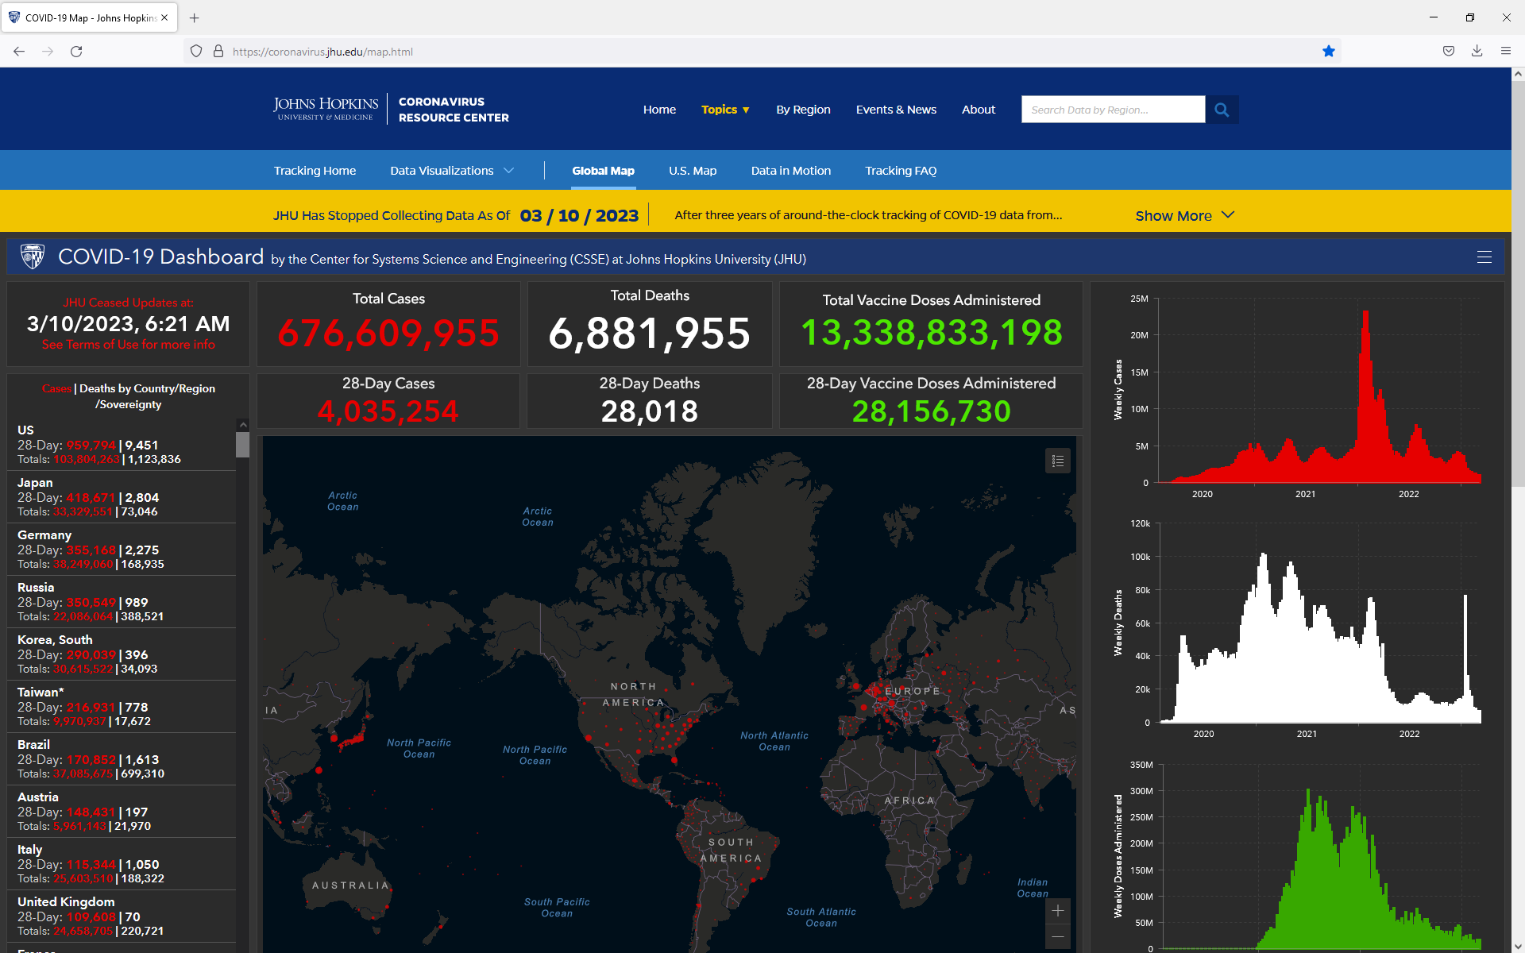

1. Power BI example to create[2]:

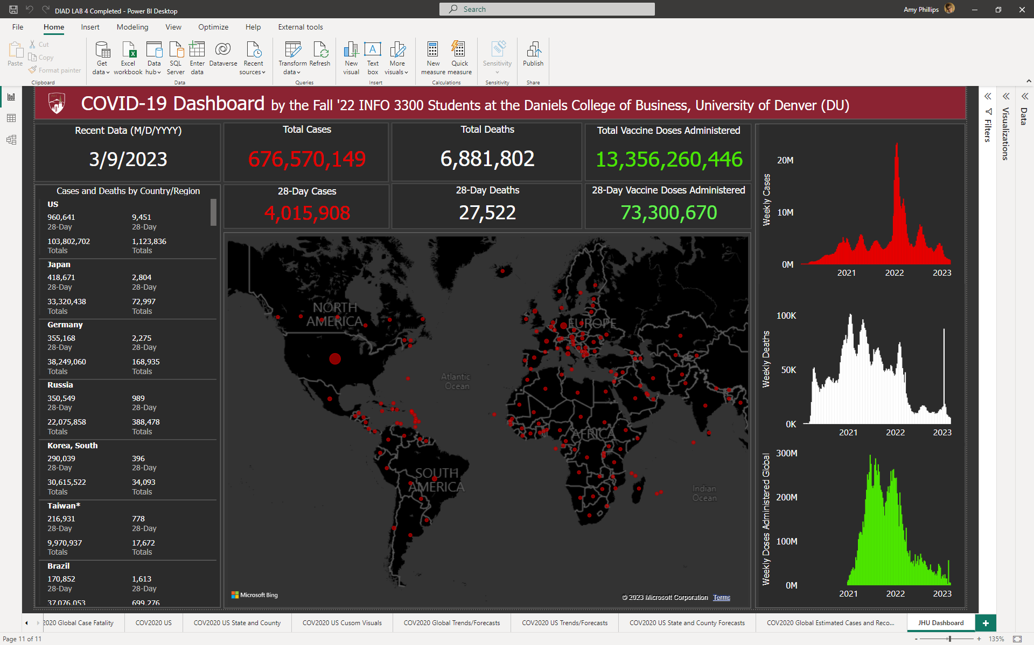 **NOTE 1:** When using the vaccinations data, only select **World** (otherwise numbers will duplicate)

**NOTE 2:** Apply the following DAX measures to the COV2020_CSSE dataset to calculate the 28-Day measures:

28-Day Cases Global = [Confirmed Recent Value] - CALCULATE([Confirmed Recent Value], (DATEADD(LASTDATE('COV2020_CSSE'[Date]), -28, DAY)))

28-Day Deaths Global = [Deaths Recent Value] - CALCULATE ([Deaths Recent Value], (DATEADD(LASTDATE('COV2020_CSSE'[Date]), -28, DAY)))

**NOTE 3:** Apply the following DAX measures to the Vaccinations_CCI dataset:

Vaccination Doses Recent Value = CALCULATE(SUM(Vaccinations_CCI[Doses_admin]), FILTER(Vaccinations_CCI, Vaccinations_CCI[Date] = MAX(Vaccinations_CCI[Date])))

28-Day Vaccine Doses Global = [Vaccination Doses Recent Value] - CALCULATE([Vaccination Doses Recent Value], (DATEADD(LASTDATE('Vaccinations_CCI'[Date]), -28, DAY)))

Weekly Doses Administered Global = [Vaccination Doses Recent Value] - CALCULATE([Vaccination Doses Recent Value], (DATEADD(LASTDATE('Vaccinations_CCI'[Date]), -7, DAY)))

**NOTE 4:** A **Calendar** table needs to be created to use a Weekly value for the column charts on the right

1. Click the Modeling tab, select **New Table,** use the following DAX in the formula bar:

Calendar = CALENDAR (

MIN ('COV2020_CSSE'[Date]),

MAX ('COV2020_CSSE'[Date])

)

1. Using the Calendar table, add a **DAX column** for the **Year**

Year = YEAR ('Calendar'[Date])

1. Using the Calendar table, add a **DAX column** for the **Week Number**

Week Number = WEEKNUM ('Calendar'[Date])

1. Using the Calendar table, add a **DAX column** for the **Week Start Date**

Week Start Date = CALCULATE (MIN ('Calendar'[Date]), ALLEXCEPT ('Calendar', 'Calendar'[Week Number], 'Calendar'[Year]))

1. Go to the **Model view**, create a **relationship** between **Calendar** and **COV2020_CSSE** and **Calendar and Vaccinations_CCI** using the **Date** field in each table.

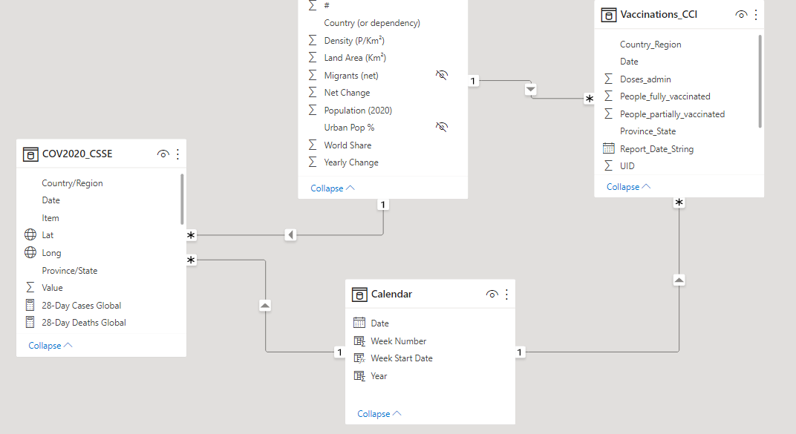

**NOTE 5:** Apply the following DAX measures to the COV2020_CSSE dataset to calculate the Weekly measures:

Weekly Confirmed Cases Global = [Confirmed Recent Value Global] - CALCULATE([Confirmed Recent Value Global], DATEADD('Calendar'[Date], -7, DAY))

Weekly Deaths Global = [Deaths Recent Value Global] - CALCULATE([Deaths Recent Value Global], (DATEADD(LASTDATE('Calendar'[Date]), -7, DAY)))

**NOTE 6**: There will be a few nuances, such as: some labeling for the multirow card (Power BI does not allow us to change colors for specific fields) and Country/Region and State being visualized on the map (a few of these are anomalies/limitations to the mapping capabilities in Power BI)

**NOTE 7:** Don’t change the “theme”; rather select background colors, wallpaper, font colors, etc… this way all the other reports are not “crippled”

1. **Save** the Power BI file as **DIAD LAB 4**

1. The wallpaper color for the page is #353535 (very dark gray), the visual background is #2b2b2b, and the visual border is #666666. The base font JHU uses is Gentona (which Power BI does not have). The lab uses Tahoma as a substitute, the red font color is #e60000, the green font color is #4ce600, the grey font color is #BDBDBD (identified from JHU’s CSS). The font size in the upper cards is 22pt, the lower cards is 20pt. The font size in the multi-row card is 8pt. The titles are all 10pt.
2. The 28-Day Vaccine Doses Administered (the card) in our model does not correlate with the JHU, nor can I validate the numbers they use on their dashboard to those being referenced here <https://coronavirus.jhu.edu/vaccines/international>. I do know that our 28-Day Cases and 28-Day Deaths correlate with JHU (multi-row card), and the 28-Day Vaccine Doses for the US are “spot on”, so the formulas work for that data. Therefore, we will use the global vaccine dataset provided as a “proof-of-concept”.